**Ianella**

Headless Lucky Llamas

Zachary Hewlett, Austin Claytor, Ben Wightman, Robert Jackson

**Table of Contents**

1. **Game Overview**
   1. Executive Summary
   2. Storyline
2. **Core Gameplay**
   1. Main Game View
   2. Core Player Activity
   3. Game Controls
   4. In-Game GUI
3. **Contextual Gameplay**
   1. Game Flow Diagram
   2. Game Mechanics
4. **Game Elements**
   1. Characters
   2. Area Designs
   3. Objects
   4. Intro Scene
   5. Menu
   6. How to Play
5. **Sound**
   1. Music
   2. Sound Effects
6. **Game Overview**
   1. **Executive Summary**

The game is a 2d, sci-fi action platformer with puzzle elements inspired from games such as Metroid and Castlevania. It pits the protagonist, Ianella, against an unknown alien race as she attempts to escape an abandoned space station with her fellow salvagers. The action will include combat with both a gun and blade, with the gun serving as a means to solve puzzles and delay the enemy and the blade serving as the primary means of destroying the enemy. In addition to enemies and puzzles, there will be bosses that are fought in multiple phases to create variety and challenge as well as add more interesting enemies to the game.

* 1. **Storyline**

Ianella was born and abandoned on the junk planet of Tarsus II. Found by a local tribe of salvagers, she learned how to aid the survival of the community by scavenging through the mountains of trash left behind by other civilizations and using what they find to create a sustainable, survivable home. As she neared her teenage years she began to grow restless and started to look to the stars for an escape from the banality that was her home. She made one last attempt to maintain her ties to the people who had raised her. She got involved with another teen her age and it almost seemed like they would be together forever. Her growing love for him clouded out her desire to escape to the stars. That is until he betrayed her with another woman and broke her heart. More determined than ever to leave her home she approached some space traders who came by to trade with her people. Eager to add someone who was an expert at scavenging goods from refuse, they accepted her onto her crew at the age of 16.

For three years she worked with these space scavengers, braving the dangers of space to search through derelict ships and space stations for anything that would make a decent profit. She was already good at spotting what was salvageable, but she became just as good at space walking, making minor repairs, and operating in the dead of space for hours on end without any support. By the age of 19 Ianella, known as Ian, had become a beloved member of the crew with her sharp wit and sarcasm meshing well with most of the crew members.

It was during this time that they encountered a drought in goods. Most of the known sectors wreckages had been picked clean by scavengers and finding useful goods to sell was becoming harder and harder. Desperate to get their hands on a rich haul, they decided to branch out into nearby unexplored sectors of space. After a weeks' long trip into uncharted territory they came upon what seemed to be an intact but abandoned space station orbiting an onyx moon.

Initial excitement turned to divided opinion as to whether to enter the space station and explore. Various members wondered as to who had created the station and why it was abandoned. The rest simply saw the potential for vast amounts of money to be had by slowly picking the station apart and selling its parts. Ianella merely saw a chance to explore something new. A shiver of excitement went down her spine and, while the rest of the crew continued to debate their options, she slipped into a space suit and flew herself to the space station to begin to search through it.

She flew into one of the cargo holds and initial exploration turned up a few human cadavers but no clues as to what killed them. Her captain, having figured out what she had done, sent various other crew members to the station to investigate other parts of it and began to guide Ianella to the bridge so she could find the captain's log and figure out what had happened here.

During this investigation she and the rest of the exploring crew are attacked by large, amorphous beings that seemed to consume all organic material in their path. Fighting the way to the bridge she confirms that it is in fact these creatures that killed all of the members of this station. She also learns of effective means of destroying them, but not why these means were unable to save the crew of the station. Shortly after she learns that these beings can change their shape and solidify into even more dangerous and terrifying creatures.

Some of the larger versions of the 'blobby things', as she calls them, exit the station and fly to the crew's' ship where they begin to devastate and subsequently destroy their ship and all on it. The remaining crew on the space station decide they must re-activate the station and send a distress signal and a warning to others and find some means of escape.

During her attempt to power up the communications satellite Ianella comes across an artificial intelligence that had been used by the crew to help run and maintain the station. This intelligence begins to guide Ianella in her attempts to restore the station and send out the distress signal.

As she fought her way through the station, several other crew members find a way to get to the shuttle hold. While Ianella finishes activating communications they begin to make their way to the hold to find a shuttle, activate it, and escape on it. Meanwhile Ianella goes into space to repair the station's communication's satellite so the distress signal is sent out. There she encounters a massive amorphous being intent on keeping her from repairing the satellite. A fight ensues, and after avoiding being flung to the far reaches of space, she manages to destroy the being and repair the satellite. With the distress signal being sent out, she starts to make her way back into the space station and towards the cargo hold, where various crew members are waiting to launch off.

She runs into what remains of the crew in the space station proper and they begin to fight their way through what is becoming a large amount of these creatures. They also start being chased by a larger version that is destroying every part of the station it crosses in an attempt to get to them.

Many are lost in the chase, but Ianella manages to defeat the creature and join the survivors in the space shuttle as it blasts off, heading back to known sectors of space. As they are flying away they witness the amorphous creatures swallow the space station. The station becomes a massive black orb that slowly hardens into an onyx sphere, similar to the moon that it is orbiting.

1. **Core Gameplay**
   1. **Main Game View**

The game is a 2D side-scrolling action platformer, with concepts and mechanics inspired by the Metroid and Castlevania series.

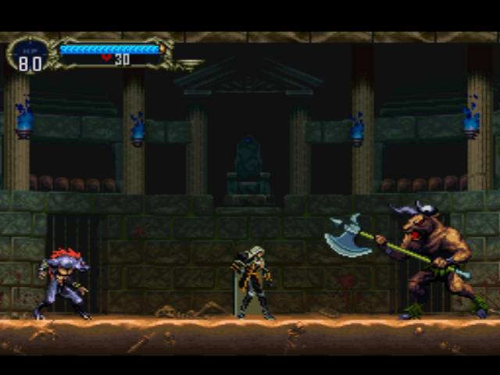

The player’s task is to explore the abandoned space station, get through each distinct area by moving the character horizontally and vertically through each room. As the player progresses, they will be attacked by various enemies and hazards and will obtain several upgrades.

* 1. **Core Player Activity**

The player can move, jump, crouch, and attack with melee and ranged weapons. Holding the jump button will make the player jump higher. Crouching allows the player to hit shorter enemies with melee and ranged attacks. Melee attacks are the main way the player will deal with enemies, dealing damage and knocking back enemies in front of the player. In the case of melee attacks, the aim is to have different animations contingent upon whether the player makes contact with an enemy or not. In the case that an enemy is hit, a short Smash-Brothers-esque animation slow down in the animation should add a more satisfying/visceral feel to combat. Ranged attacks are more suited to affecting the environment and activating mechanisms from afar, but it can also be used to stun enemies. The player must use ranged attacks carefully, as they have a long time between charges.

As the player moves around each room, the camera will follow them.

The player has a health bar that will decrease when hit by enemies and hazards; some attacks are more potent than others and will deal more damage than weaker attacks. When the player’s health has been drained completely, the game will be over and they will have to start from their most recent save.

* 1. **Game Controls**

|  |  |
| --- | --- |
| **Input** | **Action** |
| Left Arrow | Move Left |
| Right Arrow | Move Right |
| Up Arrow | Does Nothing |
| Down Arrow | Does Nothing |
| Z Key | Jump |
| X Key | Melee |
| C Key | Shoot |

* 1. **In-Game GUI**

The GUI will feature the following information:

1) Current health

1. **Contextual Gameplay**
   1. **Game Flow Diagram Part 1: From Menu to Tutorial** 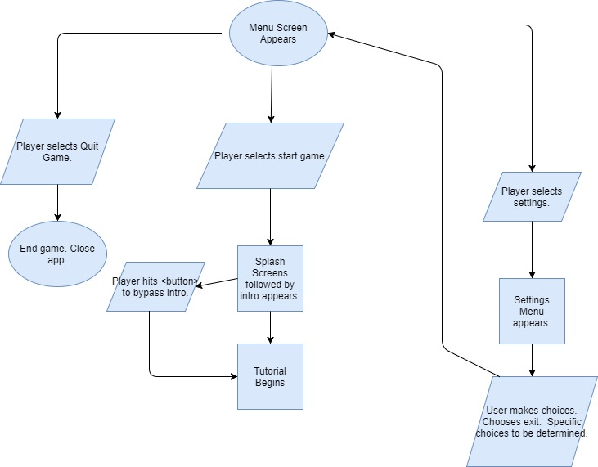

**Game Flow Diagram Part 2: From Tutorial to Stage 1**

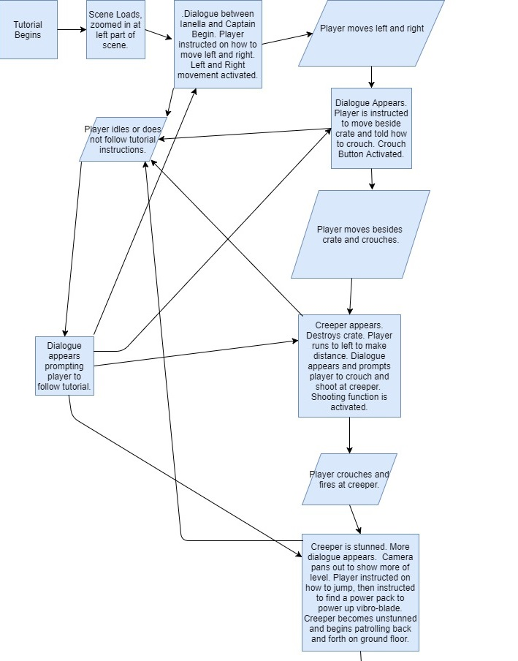

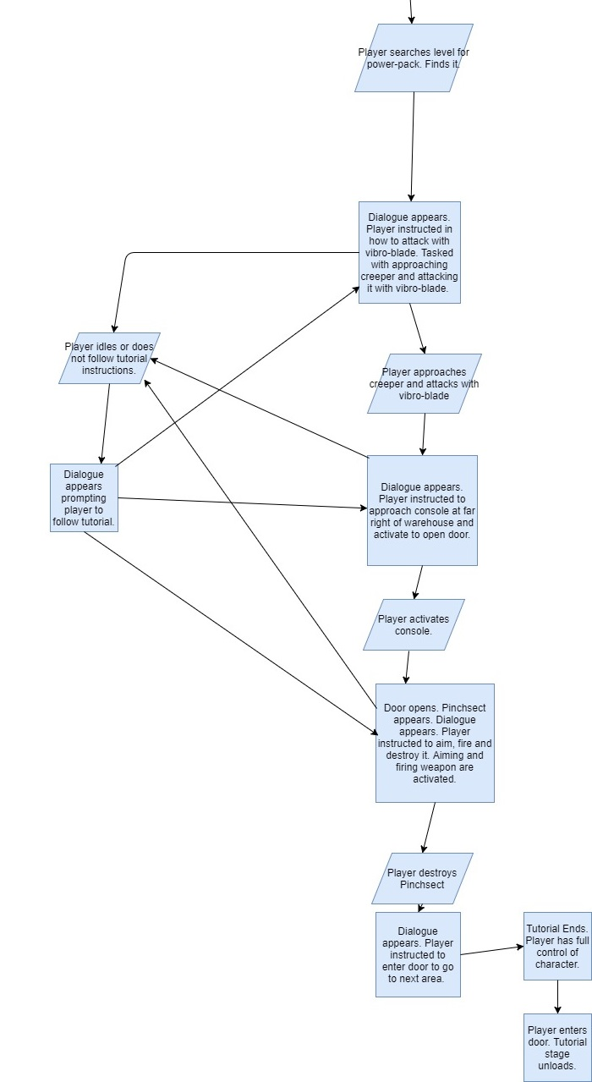

**Level Designs:**

**Tutorial Stage:**

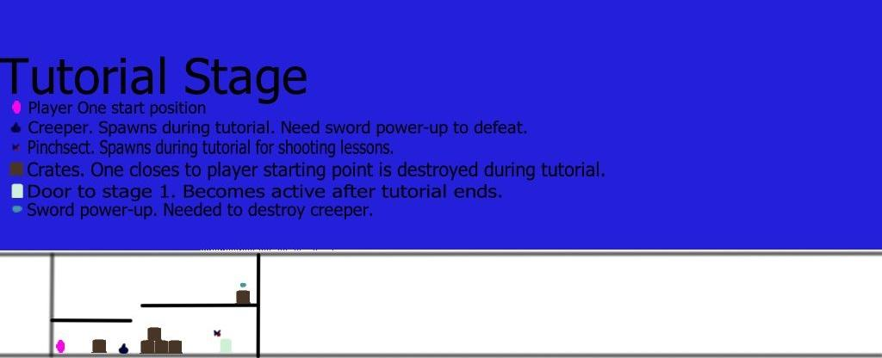

**Warehouse:**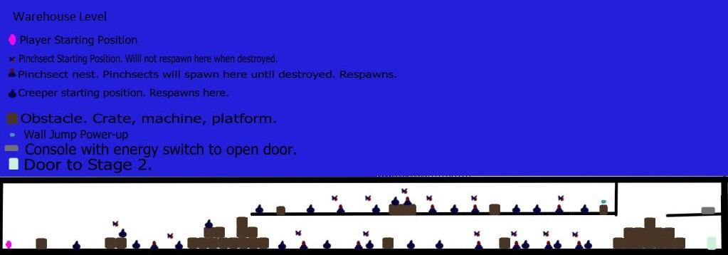

**Crew Quarters:**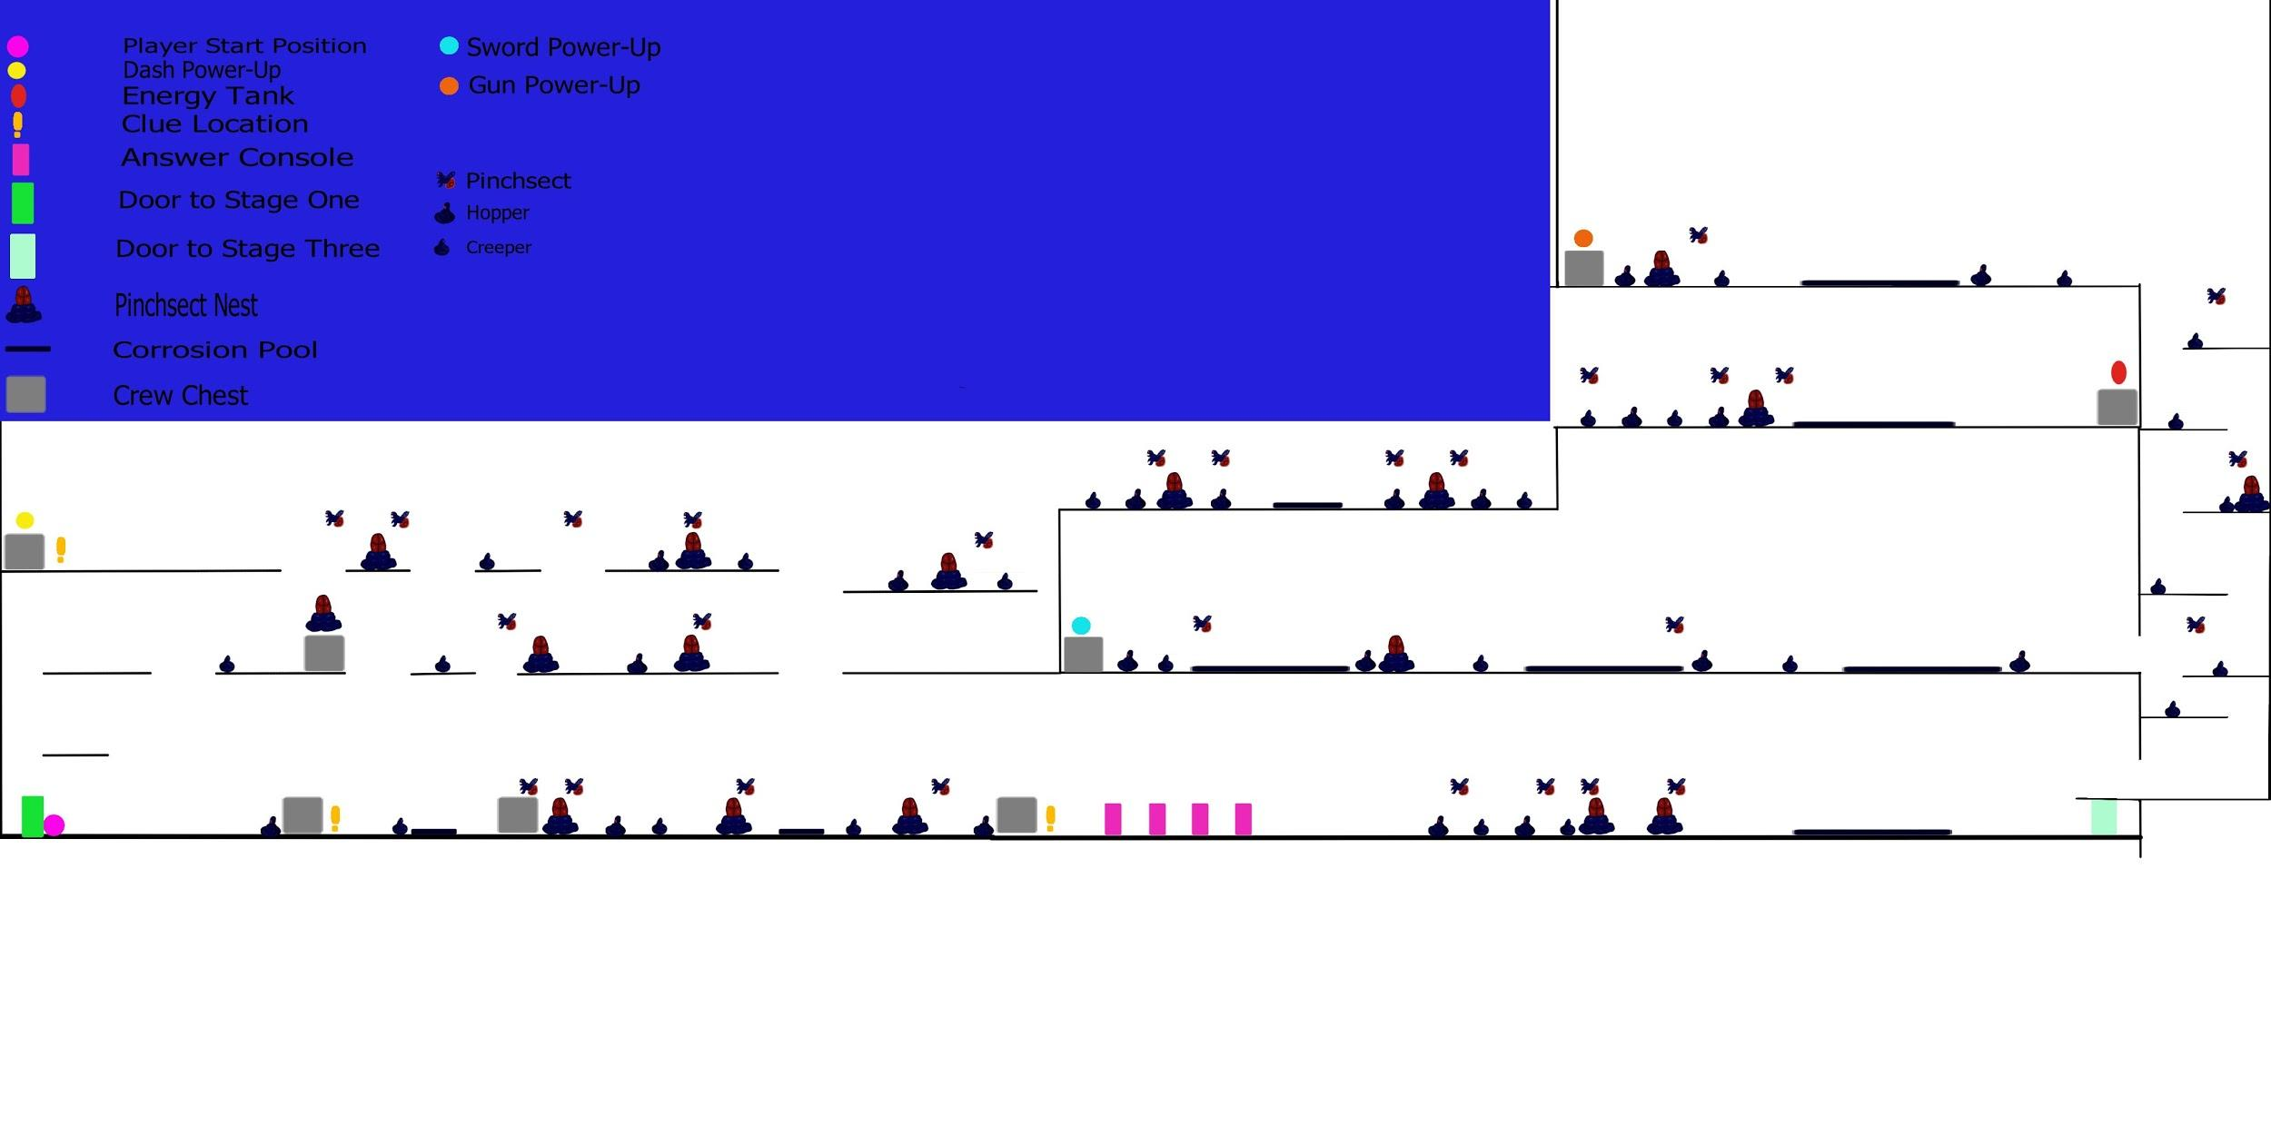

* 1. **Game Mechanics**

**Enemy Types**

**Crawler**



These enemies gently introduce the player to combat with their slow movement and small bodies. They move from left to right, turning around at edges. Crouching before striking is key to defeating these enemies.

**Hopper**



These enemies form legs to propel themselves upwards and forwards, splatting back to blob shape when they land. They are short like Crawlers, but harder to hit because of their jumping pattern. A well-timed blaster shot can immobilize them, making them easier to defeat.

**Nest**

An immobile nest-like creature that spawns Pinchsects over time. It can be destroyed with melee attacks, and will not spawn more than 3 Pinchsects at a time.

**Pinchsect**



Insect-like creatures with pincers that fly rapidly towards the player. They are new to flying, so they take a bit to build up speed and change directions. They are very fragile, even blaster shots will destroy them rather than stun them.

**Hazards**

**Corruption Pools**

These dangerous pools appear in corrupted areas, and if the player is in them they will take constant damage over time.

**Upgrades**

**Double Jump**

This upgrade allows players to jump a second time in mid-air to reach otherwise impossible to get to areas.

**Power Blade**

This upgrade increases the damage caused by their vibro-blade. Necessary to defeat the boss.

**Power Blaster**

This upgrade allows the player to stun enemies for a longer period of times with the pistol.

**Health Tank**

This upgrade gives the player an extra health bar, denoted by a blip under the health bar. This allows the player to make more mistakes without being defeated and take on more challenging enemies.

1. **Game Elements**
   1. **Characters**

**Ianella:** The protagonist of the story.

**Captain “The Boss” Borst:** The head of the Salvagers.

**Lenny, aka Spaz:** Pilot and navigator

**Mikha, aka Smart guy:** The engineer.

**The enemy, aka Those Blobby things:** Various enemies of the same amorphous race. More specific names and descriptions incoming.

* 1. **Area Designs**

Some areas in the space station are corrupted by the blobby enemies, making the environment more hostile and alien-like. In contrast, earlier areas of the game are uncorrupted sections of the space station, keeping with a traditional sci-fi aesthetic of cool metal and flashing lights.

* 1. **Objects**

**Interactable door switches:**

Pressing e at these switches will open the doors to the next stage.

* 1. **Intro Scene**

Our intro scene will have text that user can click through to read the backstory of the game.

* 1. **Menu**

The menu will appear after the intro scene, and will display the title of the game as well as menu options to play the game, and quit the game.

* 1. **How to Play**

Due to the game’s nature of constant upgrades and new abilities, the game will explain each ability and its controls as it is relevant to the player. The game will teach the player first how to move, then how to jump, then how to perform melee attacks, how to perform ranged attacks, and then how to use each upgrade as they are obtained.

1. **Sound**
   1. **Music**

The music will be mostly atmospheric loops, like a somewhat tense feel to them. They should include:

* Menu/Opening Loop
* Space Station Loop
* Boss Battle Loop
  1. **Sound Effects**

Sound effects will be included throughout the game.

Sounds for the player swinging their melee weapon, firing their ranged weapon, an impact sound for hitting enemies and objects, a sound for taking damage, and various monster sounds.